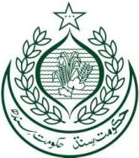
School Education & Literacy Department, Government of Sindh
RFP-6, Package-1, District Karachi Schools being managed by
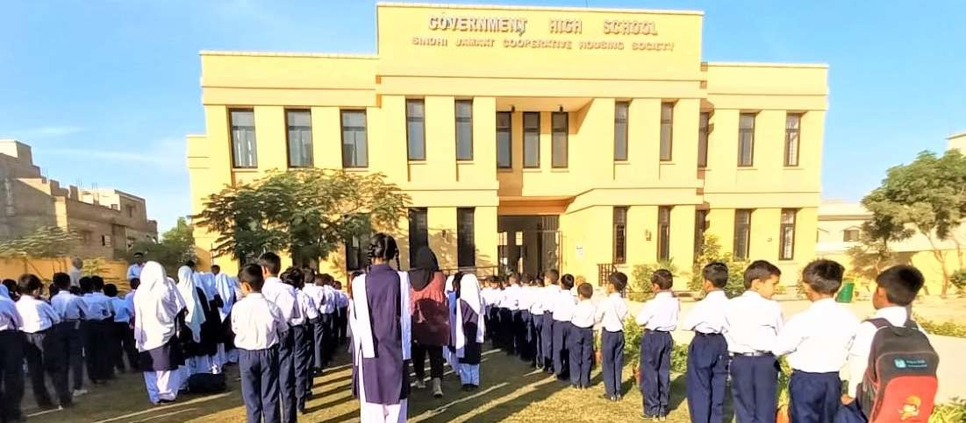
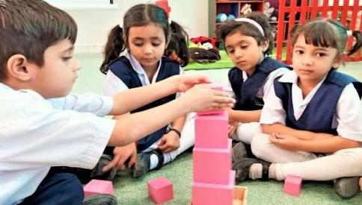
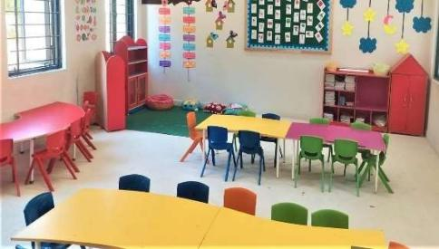
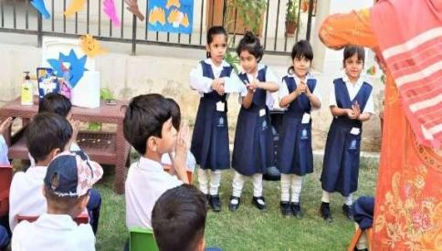
Sindh Madressah-tul-Islam Board
Quarterly KPIs Progress Report
Period of Performance:November 17, 2024 – February 16, 2025


Submitted by:

Sindh Madressah-tul-Islam Board
(Educational Management Organization)

To:

Teacher Resource Center
(Independent Expert)

KPI 2: Improved Staff Availability and Attendance

Availability of Staff
Details of teacher availability for each school are provided in the table below.
Teaching Staff Available in Schools
School Name | Government / Private | Teaching / Non- Teaching | Subjects / Department | Categories (SST, ST, PST, etc.) | Active (regular) | Transfer In | Deputation | New Hiring | Total
GBPS Sindhi Jamaat Cooperative Housing Society | Govt/Private | Teaching | HSTs= 1  JSTs= 1  JESTs=  ECT= 1  O.T=  PET=  SLT=  WI=  ITT=  PST= 9  Private= 8

